Gout management

- Scope and exceptions

This guideline applies to:

Setting | Sheffield Teaching Hospitals NHS Foundation Trust wide guideline
Individuals | All health care professionals treating patients with gout
Speciality | Rheumatology/ MSK

This guideline does not apply to:

This guideline is not for patients with an acute hot joint where the diagnosis is unclear- this is outside of the scope of this guideline.

Summary and guideline

This guideline is for the treatment of patients with a diagnosis of gout.

This guideline complements the NICE guidance NG219, published 2022, and can be used in conjunction with this document https://www.nice.org.uk/guidance/ng219 [1]

NICE have published two useful infographics on gout management which can be found here:

- Management of gout including flares: https://www.nice.org.uk/guidance/ng219/resources/visual-summary-1-longterm-management-of-gout-with-ults-pdf-11080523917

- Long-term management of gout with urate lowering treatment (ULT): https://www.nice.org.uk/guidance/ng219/resources/visual-summary-1-longterm-management-of-gout-with-ults-pdf-11080523917

Quick reference guides
Quick reference flowcharts and tables for the management of patients with gout can be found in this document by following the below links:
- Figure 1: Acute gout attack treatment
- Figure 2: Gout treat to target ULT
- Table 1: Gout treatment renal dosing

Overview and risk factors
Gout is an acute inflammatory arthritis caused by an immunological response to the presence of uric acid crystals in and around the joints, which can lead to joint damage and destruction. It is the most common inflammatory arthritis, which is increasing in prevalence, and currently affecting 2-3% of adults in the UK. Despite how common gout is, it is often misunderstood and inadequately treated.
Raised uric acid levels are a pre-requisite for gout, and is usually caused by one or more from the following list:
- Genetic predisposition/ family history of gout
- Renal impairment
- Diuretic use (higher dose = higher risk)
- Obesity
- Long term aspirin use (reduces uric acid excretion by 10%)
- Alcohol consumption (particularly beer)
- Excessive fructose consumption such as fizzy drinks and fruit juice (fructose shares the renal uric acid transporter)
Affected joints in order of frequency typically include the big toe MTPJ, midfoot, ankles, knees, elbows, wrists and hands, with acutely painful attacks that reach maximal intensity soon after onset and last 1-2 weeks. If the first attack of inflammatory arthritis is in the upper limbs this makes gout less likely. Gout is much more common in men, and extremely rare in premenopausal women.
Hyperuricaemia is common but does not mean the patient has gout. The patient must have clinical features of gout for a diagnosis.

Management of acute gout attacks
Please follow links to Figure 1: Acute gout attack treatment and Table 1: Gout treatment renal dosing
Always consider the possibility of septic arthritis in patients presenting with an acutely painful swollen joint (particularly if patient systemically ill, has a fever, in an atypical joint) and refer via the appropriate avenue.
Investigations should include CRP, U+E, FBC and uric acid. Uric acid level will be lower during an acute attack than usual as it is a negative acute phase reactant, so should be checked again 2 weeks after acute attack to get an accurate baseline uric acid level.
Acute gout attack treatment
- Patient education
- Ice treatment helps
- Start acute attack treatment as soon as possible for maximum effectiveness
- Continue treatment until the attack resolves + 2 days
Options for acute attack treatment
Treatment should always take in to account individual patient comorbidities, concomitant medications and preferences.
Consider:
- Colchicine 500mcg OD-QDS (see common colchicine interactions below)
- NSAID (eg, ibuprofen, naproxen, diclofenac or etoricoxib) + PPI, if colchicine contraindicated and eGFR at least >50 (avoid in CKD, see Table 1: Gout treatment renal dosing)
- Prednisolone +PPI can be considered if above options contraindicated or ineffective (15mg for 5 days, 10mg for 5 days, 5mg for 5 days, then stop; or higher doses of 20-40mg for 5 days then stop)
- Combination of colchicine AND steroid can be considered with caution in difficult to treat gout if monotherapy is ineffective.
- Depo-Medrone 120mg Intramuscular (IM) STAT can be considered as an alternative to the above if there are frequent acute attacks or the above strategies are contraindicated or ineffective.
- Intra-articular injection (IAI) of steroids are very effective for an acute attack of gout in one joint and can be administered via joint injection if the clinician is trained and competent to do this procedure for the particular joint involved
  - We do not anticipate that many patients outside of secondary care will receive IAI however there may be a small minority of patients where this is the best option due to contra-indications, side-effects or inefficacy of systemic treatments. If the clinician is trained and competent in IAI of the particular joint involved this may be considered. Patients can be referred to rheumatology (via the on-call rheumatology registrar) for consideration of IAI when other treatment options are not possible
  - We do not suggest IAI for patients who have an acute hot joint where diagnosis is unclear- management of the acute hot joint is outside of the scope of this guideline.
- Anakinra (IL1 receptor blocker) can be used in patients with acute attacks of gout when all other treatment is contraindicated and needs referral to rheumatology.
Colchicine further information
- Long term safety of colchicine is established in a large matched cohort study; diarrhoea, myocardial infarction, neuropathy, myalgia and bone marrow suppression are more common with colchicine than without but all except diarrhoea are uncommon (<200/10,000 patient years) [2]. Diarrhoea may occur in up to 38% of patients on BD dosing [2]. Consider interactions with other medicine and renal function.
- Common colchicine interactions:
  - Statins and fibrates can cause rhabdomyolysis (avoid/ suspend statin during treatment)
  - Drugs that increase exposure to colchicine: amiodarone, azithromycin, azole antifungals eg, fluconazole, ciclosporin, clarithromycin, diltiazem, mirabegron
  - Further interactions can be found here: https://bnf.nice.org.uk/interactions/colchicine/

Figure 1: Acute gout attack treatment
*see Table 1: Gout treatment renal dosing
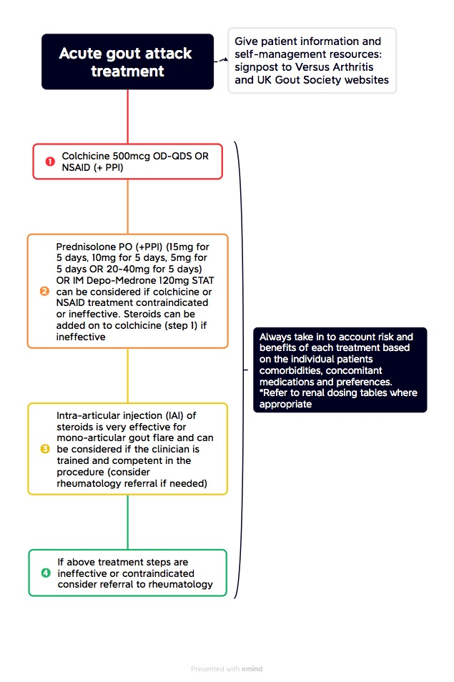

Figure 2: Gout treat to target ULT
*see Table 1: Gout treatment renal dosing
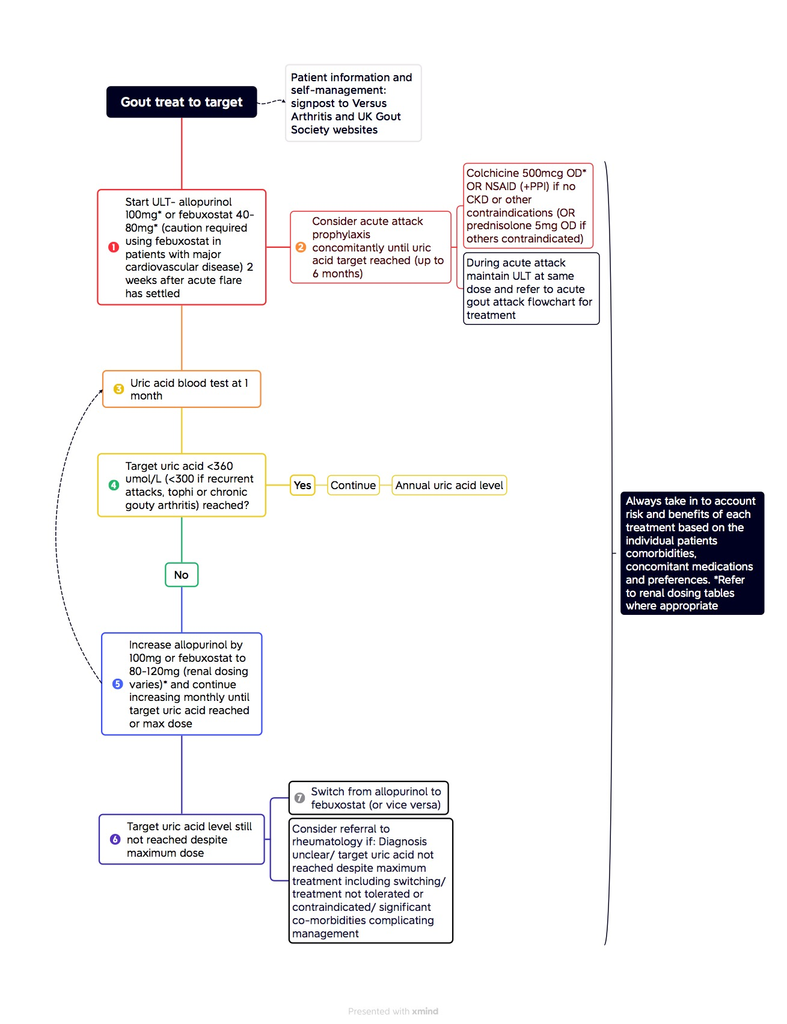

Long term management
The aim of long-term treatment is to prevent recurrent attacks, joint damage and tophi formation, in addition to reducing the cardiovascular risk of long-term hyperuricaemia. This is best achieved by ‘treat to target’ ULT ie, suppressing the uric acid <360umol/L (or <300umol/L if chronic gouty arthritis, tophi or frequent flares). ULT at target is highly effective for preventing gout flares long term, preventing hospital admission, and improving quality of life [3] [4].
Evidence shows that only approximately 1/3 patients with known gout are prescribed ULT, and only approximately 40% of patients are adherent to ULT [5]. There is a misconception that gout is a benign disease but it is an important and treatable cause of deforming and disabling arthritis. Dietary changes only contribute a small amount to lowering serum uric acid levels but for most patients with gout and significant hyperuricaemia medication is needed to lower serum uric acid to target levels.
Patients are at risk of increased attacks of acute gout for approximately 6-12 months after ULT is commenced. Patient education is important for compliance. Patients must be warned that acute attacks are to be expected and that this is a short-term problem which will improve, otherwise they may incorrectly stop treatment. This risk can be reduced by concomitant prescription of acute gout attack prophylaxis (see below).
Cardiovascular risk factors should be assessed annually (QRISK2/3 calculator) and prophylaxis started as needed.
When to treat:
Gout is a lifelong condition that progresses without treatment. Gout ULT should be offered if:
- If 2 or more attacks occur in 12 months
- If tophi are present
- If clinical gout and irreversible risk factors are present e.g. chronic kidney disease, diuretics
- Chronic gouty arthritis/ joint damage
Gout ULT can be discussed and considered after first attack of gout depending on patient preferences. It is uncommon to have one attack only ever.
When to start treatment:
Usually wait at least 2 weeks after the attack has resolved to start long term treatment with ULT, however if acute attacks are more frequent than this treatment can be started during an attack.
There is evidence to suggest that starting ULT during an acute attack does not prolong the attack and therefore can be considered depending on the individual patient and circumstances [6] [7][8].
Treating gout in hospitalised patients:
Prevalence of gout and hospital admissions for gout have increased over the last two decades. Approximately 2% of patients with gout end up having hospital admissions due to gout [3]. Acute attack treatment can be provided as per Figure 1: Acute gout attack treatment. Evidence suggests that ULT started during admission increases serum uric acid target achievement and reduces readmission rates [4]. Starting ULT as an inpatient can be considered depending on the individual patient and circumstances.
It is important that there is good communication between primary and secondary care. When a patient has been treated for an acute gout attack in hospital it is important this is communicated in the discharge letter along with the plan for follow-up serum uric acid blood test and the need for a GP follow-up appointment to consider or up-titrate ULT.
Adjust modifiable risk factors:
- Encourage patient to significantly reduce alcohol and fructose containing drinks
- Stop or reduce diuretics if possible
- Consider losartan in place of diuretics for hypertension (has uric acid lowering effect)
- Consider fenofibrate for lipid control (uric acid lowering), but note interaction with colchicine
- Consider clopidogrel in place of aspirin

Urate lowering treatment (ULT)
Please see Figure 2: Gout treat to target Table 1: Gout treatment renal dosing Table 1: Gout treatment renal dosing
- Start allopurinol OR febuxostat (xanthine oxidase inhibitors)
- Allopurinol treatment
  - ‘Start-low and go-slow’ to reduce risk of allopurinol hypersensitivity syndrome (rare but serious with a mortality risk) and also decrease risk of acute gout flares that occur with serum uric acid fluxes
  - Risk of allopurinol hypersensitivity syndrome is high in Han Chinese patients- consider avoiding allopurinol in these patients or testing for HLA B58:01 (avoid if positive)
  - Start at 100mg per day (or lower if renal failure- see Table 1: Gout treatment renal dosing)
  - Increase monthly until either target uric acid reached or maximum dose reached (can take 6-12 months or longer) in a treat to target manner (T2T)
  - Maximum dose is dependent on eGFR- 10mg per eGFR unit eg, if eGFR 30, maximum dose allopurinol would be 300mg as a rule of thumb
  - Allopurinol should be continued during acute attacks once it has been commenced
  - Continue lifelong
- Febuxostat treatment
  - Febuxostat can now be considered as an alternative first line agent to allopurinol based on NICE NG219 guidance
  - Febuxostat may be especially beneficial in those at increased risk of allopurinol hypersensitivity or where a more rapid or less complicated dose escalation may be beneficial
  - Febuxostat is green on the Traffic Light Drug List for Sheffield
  - Avoid in patients with significant cardiovascular disease (eg myocardial infarction and/or congestive cardiac failure) [9]
  - Start at 80mg, or 40mg OD if eGFR 20-30 (avoid below eGFR 20), see Table 1: Gout treatment renal dosing
  - Increase to 80mg or 120mg as per flow chart if target not reached, see Table 1: Gout treatment renal dosing
- Benzbromarone treatment (uricosuric)
  - Benzbromarone can only be prescribed in secondary care by a rheumatologist and is used off-license: please refer to rheumatology to consider this treatment if other options are not possible
  - Contraindicated in renal stone disease and severe renal impairment (eGFR <30)
  - Can be used as add on to a xanthine oxidase inhibitor or alternative treatment [10]
  - Start at 50mg OD and increase in 50mg increments until target reached or maximum dose 200mg
  - Avoid below eGFR 20
  - Need monthly LFTs for 3 months or after dose increments, then 3 monthly for 1 year and then if stable every 3-6 months thereafter
Patient involvement in treat to target ULT
The management of gout and treat to target approach can seem complicated. A useful patient sheet for treat to target therapy titration can be found on the Sheffield Aches and Pains website and helps individualise treatment and involve patients in the manangement plan, it can be found here:
  - https://www.sheffieldachesandpains.com/wp-content/uploads/sites/2/2024/04/Gout.pdf
Gout attack prophylaxis when starting ULT
Gout attack prophylaxis should always be considered when starting ULT, and is strongly suggested in some guidelines [11]. Risks and benefits should be considered for individual patients.
When ULT is started there is an increased risk of gout attacks due to the flux of uric acid. Gout attack prophylaxis, whilst up-titrating ULT, can benefit patients by preventing potentially painful flares of gout, and increase compliance with medication. It is important that patients are educated about the risk of increased flares.
Research trial data supports the safe long term use of colchicine and NSAIDs in this situation [2] [12] [13], but always take into account patient comorbidities, concomitant medications and preferences. Research studies generally involve 2-6 months of prophylaxis when started ULT. British Society of Rheumatology (BSR) gout guidelines suggest up to 6 months [10]. A large RCT has shown that colchicine prophylaxis for 6 months does decrease risk of gout flares; but often patients flare when this is stopped and it is important patients are aware of this [13][14]. Extended prophylaxis can be considered if needed, which may be especially relevant in patients with extensive burden of tophi (as suggested in the American College of Rheumatology guidelines) [11].
Options for acute gout attack prophylaxis when starting ULT:
- Colchicine 500mcg OD-BD see Table 1: Gout treatment renal dosing
- NSAIDs (avoid in CKD)
- Prednisolone 5mg
  - A minority of patients may not be able to have colchicine or NSAID prophylaxis due to side-effects or contraindications and low dose Prednisolone 5mg OD for up to 6 months can be considered. This is based on NICE NG219 and BSR guidelines; it is expert opinion based as there is a lack of high level evidence for these complex patients (who are often excluded from clinical trials) [1][10]
  - If starting ULT is a real challenge due to the frequency of attacks, an intramuscular Depo-Medrone 120mg STAT dose can be considered a few days prior to starting allopurinol; based on expert opinion
  - Patients need to be given information on steroids including sick day rules
  - Consider co-prescription of PPI for gastroprotection
  - NICE guidance suggests bone protection treatment with steroids is considered when patients are on 7.5mg prednisolone or more per day for 3 or more months. More information can be found here: https://bnf.nice.org.uk/treatment-summaries/osteoporosis/#drug-treatment.
  - Consider monitoring blood glucose levels. More information can be found here: https://abcd.care/sites/default/files/site_uploads/JBDS_Guidelines_Archive/JBDS_08_Steroids_DM_Guideline_FINAL_28052021_Archive.pdf
Ongoing management
  - Aim to keep urate below target <360 umol/L (or <300 umol/L if chronic gouty arthritis, tophi or frequent flares) which will deplete total body urate load over time
  - Uric acid should be monitored annually once at target
  - It can take many months for attacks to reduce in frequency once at target, and years for tissue load of urate to dissipate, especially if high tophi burden
  - Extended acute attack prophylaxis can be used if needed
  - Treatment is usually lifelong, and this should be explained to the patient
Who to refer to rheumatology?
Patients should be referred to Rheumatology if:
  - There is significant uncertainty regarding the diagnosis
  - Their symptoms are not resolving despite the above treatment, including switch to febuxostat where appropriate, particularly if urate remains elevated
  - Treatment is contraindicated
  - Genuine intolerance to allopurinol and febuxostat
  - There are significant complicating co-morbidities, particularly including eGFR <30/ CKD 3b-5
  - Organ transplant
  - Complex patients where management is difficult in primary care
Patient education sources
Patient education in gout management is central to combat myths and improve adherence to treatment.

Links to patient information:
  - Gout | Causes, symptoms, treatments | Versus Arthritis
  - Final_All_about_gout_and_treatment_2021.pdf (ukgoutsociety.org)

A very useful patient sheet for treat to target therapy titration can be found on the Sheffield Aches and Pains website and helps individualise treatment and involve patients in the manangement plan, it can be found here:
  - https://www.sheffieldachesandpains.com/assets/Gout.pdf

Table 1: Gout treatment renal dosing
eGFR | CKD | Colchicine short-term acute attack treatment [15] | Colchicine long-term colchicine prophylaxis [10] | Allopurinol start dose [10] [16] | Allopurinol max dose | Febuxostat [15] | Febuxostat max dose | Benzbromarone start dose [16] [15] | Benzbromarone max dose [16] [15]
>90 | 1 | 500mcg BD-QDS | 500mcg OD-BD | 100mg OD | 10mg/ 1 eGFR unit | 80mg | 120mg | 50mg | 200mg
61-90 | 2 | 500mcg BD-QDS | 500mcg OD-BD | 100mg OD | 10mg/ 1 eGFR unit | 80mg | 80mg | 50mg | 200mg
46-60 | 3A | 500mcg OD-BD | 500mcg OD | 50/100mg alternate days | 10mg/ 1 eGFR unit | 80mg | 80mg | 50mg | 200mg
31-45 | 3B | 500mcg OD-BD | 500mcg alternate days | 50mg OD | 10mg/ 1 eGFR unit | 80mg | 80mg | 50mg | 200mg
16-30 | 4 | 500mcg OD-BD | 500mcg alternate days/ or every three days (eGFR 10-30) | 50mg alternate days | 10mg/ 1 eGFR unit | 40mg (eGFR 20-30)  Avoid eGFR below 20 (lack of data) | 40mg  Avoid eGFR below 20 (lack of data) | Avoid (ineffective under eGFR 20) | Avoid (ineffective under eGFR 20)
5-15 | 5 | eGFR <10 avoid | Avoid below eGFR 10 | 50mg 2 x per week | 10mg/ 1 eGFR unit | Avoid | avoid | avoid | avoid
<5 | 5 | Avoid | avoid | 50mg 1 x per week | 10mg/ 1 eGFR unit | avoid | avoid | avoid | avoid

References

[1] NICE. Gout: diagnosis and management NICE guideline 2022.
[2] Roddy E, Bajpai R, Forrester H, Partington RJ, Mallen CD, Clarson LE, et al. Safety of colchicine and NSAID prophylaxis when initiating urate-lowering therapy for gout: propensity score-matched cohort studies in the UK Clinical Practice Research Datalink. Ann Rheum Dis 2023;82:1618–25. https://doi.org/10.1136/ard-2023-224154.
[3] Russell MD, Roddy E, Rutherford AI, Ellis B, Norton S, Douiri A, et al. Treat-to-target urate-lowering therapy and hospitalizations for gout: results from a nationwide cohort study in England. Rheumatol (United Kingdom) 2023;62:2426–34. https://doi.org/10.1093/rheumatology/keac638.
[4] Russell MD, Ameyaw-Kyeremeh L, Dell’Accio F, Lapham H, Head N, Stovin C, et al. Implementing treat-to-target urate-lowering therapy during hospitalizations for gout flares. Rheumatology 2023:1–8. https://doi.org/10.1093/rheumatology/kead574.
[5] Kuo CF, Grainge MJ, Mallen C, Zhang W, Doherty M. Rising burden of gout in the UK but continuing suboptimal management: A nationwide population study. Ann Rheum Dis 2015;74:661–7. https://doi.org/10.1136/annrheumdis-2013-204463.
[6] Taylor TH, Mecchella JN, Larson RJ, Kerin KD, MacKenzie TA. Initiation of allopurinol at first medical contact for acute attacks of gout: A randomized clinical trial. Am J Med 2012;125:1126-1134.e7. https://doi.org/10.1016/j.amjmed.2012.05.025.
[7] Hill EM, Sky K, Sit M, Collamer A, Higgs J. Does starting allopurinol prolong acute treated gout? a randomized clinical trial. J Clin Rheumatol 2015;21:120–5. https://doi.org/10.1097/RHU.0000000000000235.
[8] Jia E, Zhang Y, Ma W, Li B, Geng H, Zhong L, et al. Initiation of febuxostat for acute gout flare does not prolong the current episode: A randomized clinical trial. Rheumatol 2021;60:4199–204. https://doi.org/10.1093/rheumatology/keaa908.
[9] White WB, Saag KG, Becker MA, Borer JS, Gorelick PB, Whelton A, et al. Cardiovascular Safety of Febuxostat or Allopurinol in Patients with Gout. N Engl J Med 2018:1200–10. https://doi.org/10.1056/nejmoa1710895.
[10] Hui M, Carr A, Cameron S, Davenport G, Doherty M, Forrester H, et al. The British Society For Rheumatology guideline for the management of gout. Rheumatol (United Kingdom) 2017;56:e1–20. https://doi.org/10.1093/rheumatology/kex156.
[11] FitzGerald JD, Dalbeth N, Mikuls T, Brignardello-Petersen R, Guyatt G, Abeles AM, et al. 2020 American College of Rheumatology Guideline for the Management of Gout. Arthritis Care Res 2020;72:744–60. https://doi.org/10.1002/acr.24180.
[12] Pisaniello HL, Fisher MC, Farquhar H, Vargas-Santos AB, Hill CL, Stamp LK, et al. Efficacy and safety of gout flare prophylaxis and therapy use in people with chronic kidney disease: a Gout, Hyperuricemia and Crystal-Associated Disease Network (G-CAN)-initiated literature review. Arthritis Res Ther 2021;23:1–18. https://doi.org/10.1186/s13075-021-02416-y.
[13] Latourte A, Bardin T, Richette P. Prophylaxis for acute gout flares after initiation of urate-lowering therapy. Rheumatol (United Kingdom) 2014;53:1920–6. https://doi.org/10.1093/rheumatology/keu157.
[14] Stamp L, Horne A, Mihov B, Drake J, Haslett J, Chapman PT, et al. Is colchicine prophylaxis required with start-low go-slow allopurinol dose escalation in gout? A non-inferiority randomised double-blind placebo-controlled trial. Ann Rheum Dis 2023;82:1626–34. https://doi.org/10.1136/ard-2023-224731.
[15] Ashley C, Dunleavy A. The renal drug handbook: The ultimate prescribing guide for renal practitioners, 4th edition. 2017. https://doi.org/10.1201/9781315379456.
[16] Harty T. Review Therapeutics in rheumatology and the kidney 2022:1–12.

- Appendices

Link to Sheffield Aches and Pains website: Gout/CPPD - Sheffield Aches and Pains

Link to NICE Gout guidance 2022: Recommendations | Gout: diagnosis and management | Guidance | NICE
Colchicine interactions: https://bnf.nice.org.uk/interactions/colchicine/
NICE osteoporosis guidance: https://bnf.nice.org.uk/treatment-summaries/osteoporosis/#drug-treatment.
Steroids and blood sugars/ diabetes: https://abcd.care/sites/default/files/site_uploads/JBDS_Guidelines_Archive/JBDS_08_Steroids_DM_Guideline_FINAL_28052021_Archive.pdf
Links to patient information:
  - Gout | Causes, symptoms, treatments | Versus Arthritis
  - Final_All_about_gout_and_treatment_2021.pdf (ukgoutsociety.org)

Patient treat to target sheet: https://www.sheffieldachesandpains.com/assets/Gout.pdf

- Document control

Ref
Version | 1
Status | Approved
Document Sponsor | Dr Rachel Tattersall
Controlled Document Lead / Author* | Dr Judith Jade (Rheumatology Registrar), Dr Stuart Carter (Rheumatology Consultant)
Approval body | Rheumatology Governance Meeting
Date approved | 07.03.2024
Ratification body | Rheumatology Governance Meeting
Date ratified | 07.03.2024
Issue date | 09.05.2024
Review date | 09.05.2027

- Version history
Version | Date issued | Brief summary of changes | Author
Version number | Date | Summary of changes | Author (first name and last name)
1 | 09/05/2024 |  | Judith Jade

- Consultation and review
Groups / persons consulted | Date
Sheffield Teaching Hospital MDT meeting and Rheumatology Consultant body consulted | 31/08/2023
Consultation with Sheffield Local Medical Committee | 08/02/2024

- Document imprint

© Sheffield Teaching Hospitals NHS Foundation Trust 2022. All rights reserved. Re-use of all or any part of this document is governed by copyright and the ‘Re-use of Public Sector Information Regulations 2015. SI 2015. No. 1415’. Information can be obtained from sth.infogov@nhs.net

Guideline template version 2.4

